Colin Keenan

ECE 5470

3-1-2020

Homework 5

1. Fourier Spectrum and Average Value

# Compute, Center, and Enhance Fourier Spectrum for Fig5-1a.jpg, Fig5-1b.jpg, Fig5-1c.jpg, and Fig5-1d.jpg

clear

imageA = imread('Fig5-1a.jpg');

imageB = imread('Fig5-1b.jpg');

imageC = imread('Fig5-1c.jpg');

imageD = imread('Fig5-1d.jpg');

[AS, AcS, AeS] = cceFourierSpec(imageA);

[BS, BcS, BeS] = cceFourierSpec(imageB);

[CS, CcS, CeS] = cceFourierSpec(imageC);

[DS, DcS, DeS] = cceFourierSpec(imageD);

figure();

% Original Images

subplot(4,4,1)

imshow(imageA);

title("Fig5-1a.jpg");

subplot(4,4,2)

imshow(imageB);

title("Fig5-1b.jpg");

subplot(4,4,3)

imshow(imageC);

title("Fig5-1c.jpg");

subplot(4,4,4)

imshow(imageD);

title("Fig5-1d.jpg");

% Fourier Spectrums

subplot(4,4,5)

imshow(AS, []);

title("Fig5-1a.jpg Spectrum");

subplot(4,4,6)

imshow(BS, []);

title("Fig5-1b.jpg Spectrum");

subplot(4,4,7)

imshow(CS, []);

title("Fig5-1c.jpg Spectrum");

subplot(4,4,8)

imshow(DS, []);

title("Fig5-1d.jpg Spectrum");

% Centered Fourier Spectrums

subplot(4,4,9)

imshow(AcS, []);

title("Fig5-1a.jpg Centered Spectrum");

subplot(4,4,10)

imshow(BcS, []);

title("Fig5-1b.jpg Centered Spectrum");

subplot(4,4,11)

imshow(CcS, []);

title("Fig5-1c.jpg Centered Spectrum");

subplot(4,4,12)

imshow(DcS, []);

title("Fig5-1d.jpg Centered Spectrum");

% Enhanced Centered Spectrums

subplot(4,4,13)

imshow(AeS, []);

title("Fig5-1a.jpg Enhanced Centered Spectrum");

subplot(4,4,14)

imshow(BeS, []);

title("Fig5-1b.jpg Enhanced Centered Spectrum");

subplot(4,4,15)

imshow(CeS, []);

title("Fig5-1c.jpg Enhanced Centered Spectrum");

subplot(4,4,16)

imshow(DeS, []);

title("Fig5-1d.jpg Enhanced Centered Spectrum");

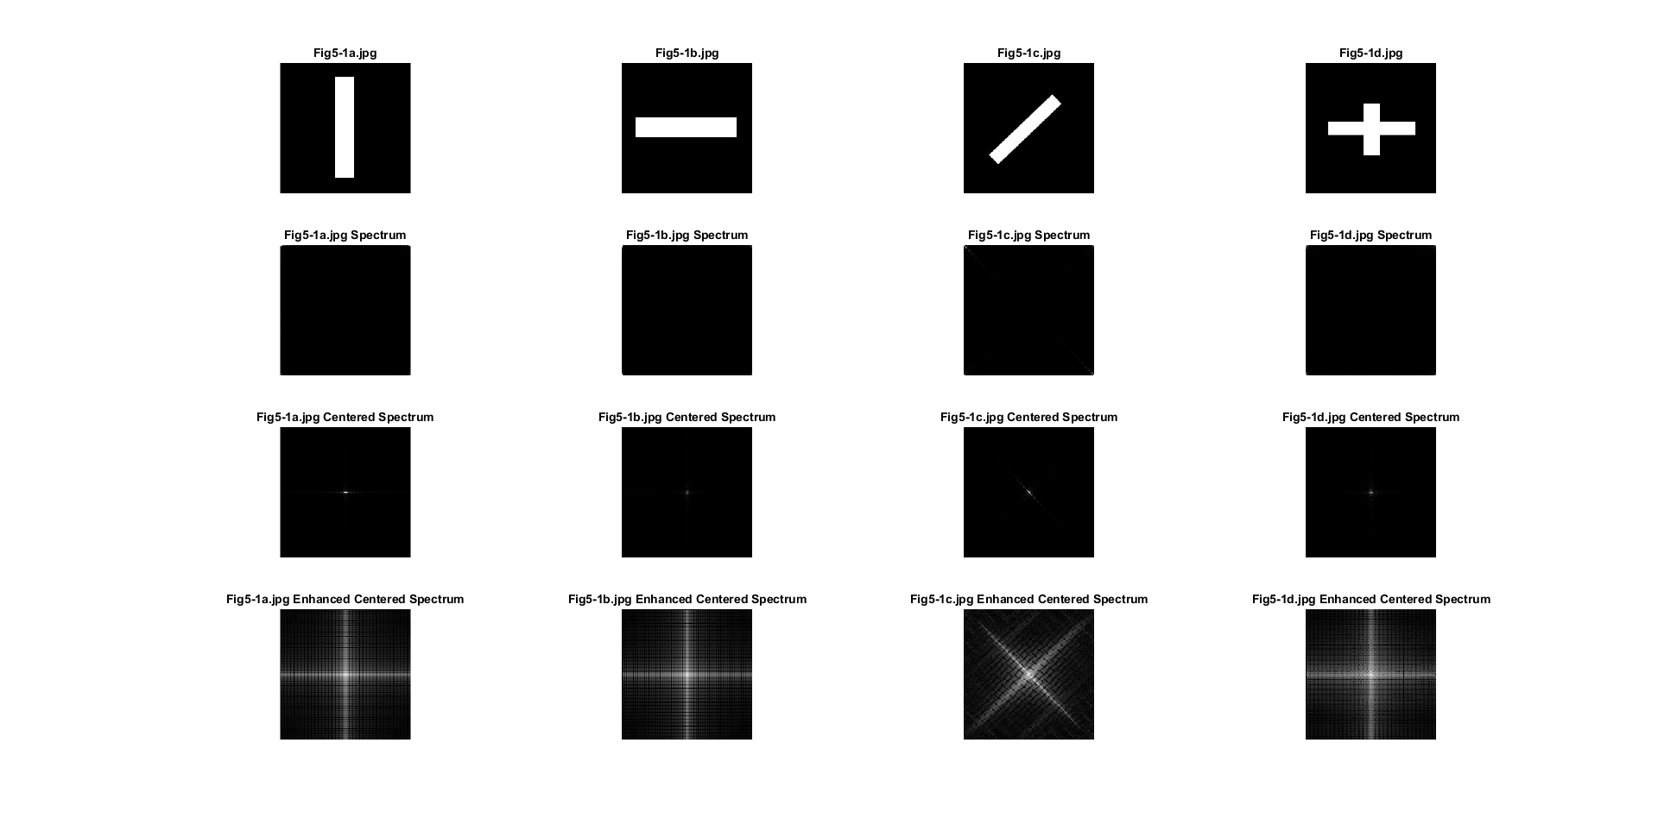

2. Ideal Low-Pass Filtering

# Apply an Ideal Low Pass Filter to Fig5-2a.jpg and Fig5-2b.jpg with D0 values of 20 and 60

clear

imageA = imread('Fig5-2a.jpg');

imageB = imread('Fig5-2b.jpg');

Ailpf20 = ilpf(imageA, 20);

Ailpf60 = ilpf(imageA, 60);

Bilpf20 = ilpf(imageB, 20);

Bilpf60 = ilpf(imageB, 60);

figure();

% Fig5-2a.jpg

subplot(2,3,1)

imshow(imageA);

title("Before Filter");

subplot(2,3,2)

imshow(Ailpf20, []);

title("After ILPF with D0 of 20");

subplot(2,3,3)

imshow(Ailpf60, []);

title("After ILPF with D0 of 60");

% Fig5-2b.jpg

subplot(2,3,4)

imshow(imageB);

title("Before Filter");

subplot(2,3,5)

imshow(Bilpf20, []);

title("After ILPF with D0 of 20");

subplot(2,3,6)

imshow(Bilpf60, []);

title("After ILPF with D0 of 60");

Explanation: The above code filters the images using an ideal low-pass filter which does smooth out the image, however there is an odd halo-like artifacting on big changes between light and dark.

3. Butterworth Low-Pass Filtering

# Apply a Butterworth Low Pass Filter to Fig5-2a.jpg and Fig5-2b.jpg with D0 values of 20 and 60

clear

imageA = imread('Fig5-2a.jpg');

imageB = imread('Fig5-2b.jpg');

Ablpf20 = blpf(imageA, 20);

Ablpf60 = blpf(imageA, 60);

Bblpf20 = blpf(imageB, 20);

Bblpf60 = blpf(imageB, 60);

figure();

% Fig5-2a.jpg

subplot(2,3,1)

imshow(imageA);

title("Before Filter");

subplot(2,3,2)

imshow(Ablpf20, []);

title("After BLPF with D0 of 20");

subplot(2,3,3)

imshow(Ablpf60, []);

title("After BLPF with D0 of 60");

% Fig5-2b.jpg

subplot(2,3,4)

imshow(imageB);

title("Before Filter");

subplot(2,3,5)

imshow(Bblpf20, []);

title("After BLPF with D0 of 20");

subplot(2,3,6)

imshow(Bblpf60, []);

title("After BLPF with D0 of 60");

Explanation: The above code filters the images using a Butterworth low-pass filter, which when compared with the previous ideal filter is much better at showing a smooth transition between dark and light without the odd halo-artifacting seen with the ideal filter.

4. Gaussian Low-Pass Filtering

# Apply an Gaussian Low Pass Filter to Fig5-2a.jpg and Fig5-2b.jpg with D0 values of 20 and 60

clear

imageA = imread('Fig5-2a.jpg');

imageB = imread('Fig5-2b.jpg');

Aglpf20 = glpf(imageA, 20);

Aglpf60 = glpf(imageA, 60);

Bglpf20 = glpf(imageB, 20);

Bglpf60 = glpf(imageB, 60);

figure();

% Fig5-2a.jpg

subplot(2,3,1)

imshow(imageA);

title("Before Filter");

subplot(2,3,2)

imshow(Aglpf20, []);

title("After GLPF with D0 of 20");

subplot(2,3,3)

imshow(Aglpf60, []);

title("After GLPF with D0 of 60");

% Fig5-2b.jpg

subplot(2,3,4)

imshow(imageB);

title("Before Filter");

subplot(2,3,5)

imshow(Bglpf20, []);

title("After GLPF with D0 of 20");

subplot(2,3,6)

imshow(Bglpf60, []);

title("After GLPF with D0 of 60");

Explanation: The above code filters the images using a gaussian low-pass filter, which when compared with the previous two filters has the smoothest transitions between intensities.

# Appendix (Functions Used)

function [S,cS,eS] = cceFourierSpec(imag)

% Description: Compute, Center, and Enhance a Fourier Spectrum of an Image

% Base FFT

F = fft2(im2double(imag));

% Spectrum

S = abs(F);

% Centered Spectrum

cF = fftshift(F);

cS = abs(cF);

% Enhanced Spectrum

eS = log(1+abs(cF));

end

function filtered = ilpf(imag, D0)

% Description: Perform an Ideal Low-Pass Filter to an image with the given sigma

% Initial Variables

[M,N] = size(imag);

F = fft2(im2double(imag));

% Mesh grid generation

u = 0:(M-1);

v = 0:(N-1);

idx = find(u>M/2);

u(idx)= u(idx)-M;

idy = find(v>N/2);

v(idy)= v(idy)-N;

[U,V] = meshgrid(v,u);

D = sqrt(U.^2+V.^2);

% Ideal Filter

H = double(D<=D0);

% Apply Filter

G = F.*H;

filtered = real(ifft2(G));

end

function filtered = blpf(imag, D0)

% Description: Perform an Butterworth Low-Pass Filter to an image with the given sigma

% Initial variables

[M,N] = size(imag);

F = fft2(im2double(imag));

% Mesh grid generation

u = 0:(M-1);

v = 0:(N-1);

idx = find(u>M/2);

u(idx)= u(idx)-M;

idy = find(v>N/2);

v(idy)= v(idy)-N;

[U,V] = meshgrid(v,u);

D = sqrt(U.^2+V.^2);

% Butterworth Filter: default n value

n=2;

H=1./(1+(D./D0).^(2*n));

% Apply Filter

G = F.*H;

filtered = real(ifft2(G));

end

function filtered = glpf(imag, D0)

% Description: Perform an Gaussian Low-Pass Filter to an image with the given sigma

% Initial variables

[M,N] = size(imag);

F = fft2(im2double(imag));

% Mesh grid generation

u = 0:(M-1);

v = 0:(N-1);

idx = find(u>M/2);

u(idx)= u(idx)-M;

idy = find(v>N/2);

v(idy)= v(idy)-N;

[U,V] = meshgrid(v,u);

D = sqrt(U.^2+V.^2);

% Gaussian Filter

H = exp(-(D.^2)./(2*(D0^2)));

% Apply Filter

G = F.*H;

filtered = real(ifft2(G));

end